
Semester I 2025/2026

Subject | : | Permodelan dan Rekabentuk Sistem Enterprise (SECP3744)
Task | : | NEWSLETTER on Industrial Talk
Title | : | PPG Industrial Talk
Due | : | 17/11/2025
Submission | : | Submit softcopy (in .pdf format) via e-learning and e-portfolio, LinkedIn.

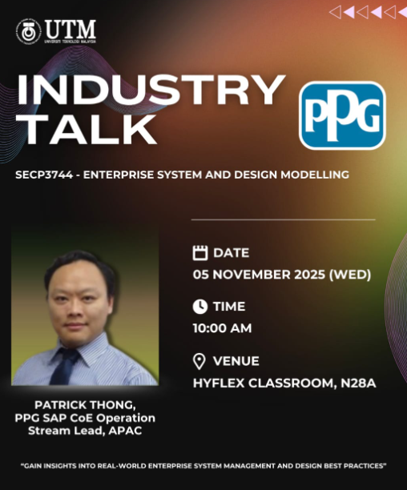

This is a GROUP ASSIGNMENT and it is based on the industrial talk by PPG.

Instruction:
- Students are required to prepare ONE (1) PAGES NEWSLETTER on:
- Industrial Talk by PPG.
- For this Industrial Talk, the content should include a description on:
  - Summary of the talk.
  - The technologies and issues discussed in the talk.
  - The reflection from the talk (individual).
**Note: The content of your newsletter is your own opinion and views. You may refer the rubric of newsletter in the next page.
- This will contribute 10% of the course assessment.
- Follow the Format of Newsletter as follows:
  - Portrait layout.
  - Justify alignment for text description.
  - Include the date in each newsletter.
  - Include your name&matric card at the bottom in each newsletter.
  - Design your newsletters using your own creativities.
- You may refer the following link as your reference for your newsletter making:
- https://www.postermywall.com/index.php/art/template/2375c421a3e60145601c826d45ab2762/newsletter-poster-template#.YY6JYmBBw2w
- https://www.postermywall.com/index.php/posterbuilder/copy/3a7b215731335fa7c81eb37d3fe661f6
- PLAGIARISM of the content is prohibited. If any of the content is known to be copied from other website/review/blogs, you will be given ZERO (0) mark.
- You can get photos/information from other resources, but you must include credits (In citation/link) to the original owners.

Rubric for Two (2) Pages Newsletter

Criteria | Excellent  10-7 | Fair  6-4 | Poor  3-0 | WEIGHTAGE | MARKS
Informative and Attractive | - Provide accurate information (content).  - All required information is presented in a logical order. | - Some information (content) is inaccurate, but presented in a logical order.  - Very few required information is missing and presented in a logical order. | - Most Information (content) are inaccurate, or not presented in a logical order, making it difficult to follow.  - Most required information is missing and not presented in a logical order, making it difficult to follow. | 10 | ____ X 10  10
Contents | - Newsletter on Industrial Visit contents:  Summary, the discussed issue, reflection and so on. |  |  | 30 |  | ____ X 30  10
 | - All contents included  - Very good presentation of content and well organized.  - Use many graphics and pictures. | - Included but not well covered  - Moderate presentation of content and well organized  - Use moderate graphics and pictures. | - Included but poorly covered  - Lack of content and not organized properly.  - Use inappropriate graphics or pictures.
Reflection | - Newsletter on Industrial Visit:  What is the motivation/ insights/information did you gain from this industrial visit on how the innovation helps human life in particular aspect? |  |  | 30 | ____ X 30  10
 | - Excellent explanation | - Fair explanation | - Poor explanation
Features | - Include all required features, such as main article, graphics with captions and editorials.  - All features relate to the subject and are appropriate for the targeted audience.  - The layout is creative. | - Not all required features, such as main article, graphics with captions and editorials.  - All features are almost related to the subject and are appropriate for the targeted audience.  - The layout shows some degree of creativity but is not organized logically and/or is cluttered. | - Lack of features, such as main article, graphics with captions and editorials.  - All features are unrelated to the subject and are inappropriate for the targeted audience.  - The layout is messy, disorganized or cluttered.  . | 10 | ____ X 10  10
Organization and Structure | - Structure of text is interesting and organized very well, easy to understand. | - Structure of text is quite interesting and organized. | - Most parts of the structure of text are not really interesting and unorganized. | 10 | ____ X 10  10
Text | - All texts are easy to read and clear explanation.  - Use appropriate font size.  - Use not more than three different font styles. | - Most texts are easy to read and clear explanation.  - Use appropriate font size.  - Use more than three different font styles. | - Some texts are difficult to read unclear explanation.  - Use medium font size.  - Use more than four different font styles. | 5 | ____ X 5  10
Timeliness | - Due on time | - Due one day late | - Due more than one day late | 5 | ____ X 5  10
Total |  |  |  |  | / 100

